

MISSION: To leverage career opportunities for individuals with barriers to employment through collaboration and partnership.

Who is Nexus?
A collaboration of experienced employment service providers and local businesses who are working together to expand employment opportunities for individuals with barriers to employment.

What does Nexus do?
Provides an opportunity to focus on the workforce needs of regional businesses and a place for collaboration and sharing of ideas and information.

Employer Services Nexus Provides:
- Market current employment needs
- Access to an untapped pool of applicants
- Monthly networking meetings
- Single point of contact for businesses (if desired by business)
- Sharing job leads, best practices, brainstorm difficult cases
- Business presentations

Who are Nexus Community Partners?
- Missouri Vocational Rehabilitation
- Community Rehabilitation Providers
- Missouri Job Centers
- Missouri Department of Corrections
- Rehabilitation Services for the Blind
- Missouri Department of Social Services
- Missouri Department of Mental Health
- Community Action Agencies
- Other Non-Profit Organizations

How to Get Involved?
- Attend regular Nexus meetings to network, build partnerships and collaborate with businesses and employment service professionals.


Find the Nexus group near you!
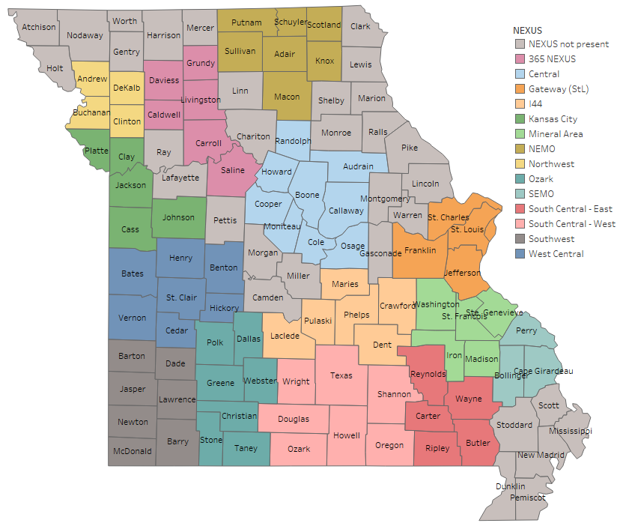

Central Gateway (STL) Kansas City Ozark
West Central Mineral Area
South Central-West South Central-East SEMO
Southwest I44 NEXUS NEMO
Northwest
365 NEXUS
Josiah.Melzer@dss.mo.gov MOGatewayNexus@gmail.com gkcemploymentnexus@gmail.com ozarkregionnexus@gmail.com Tonya@midconholdings.com Macey.L.LaRue@dss.mo.gov southcentralwestnexus@gmail.com southcentraleastnexus@gmail.com semoregionnexus@gmail.com swmonexus@gmail.com Mary.morarity@dss.mo.gov NorthEastMONexus@gmail.com Helen.Bishop-Randle@dss.mo.gov
alicia.e.scharpenburg@dss.mo.gov
Meetings: 2nd Tuesday of even numbered months, 2:00-3:00pm Meetings: 2nd Friday of each month, 9:30-10:30am
Meetings: 2nd Wednesday of each month, 9:00-10:30am Meetings: 4th Tuesday of each month, 9:00-10:00am Meetings: 4th Tuesday of each month, 10:00-11:00am Meetings: 1st Wednesday of each month, 10:00-11:00am Meetings: 1st Thursday of the month, 10:30-11:30am Meetings: 3rd Wednesday of the month, 1:00-2:00pm Meetings: 3rd Monday of the month, 2:00-3:00pm Meetings: 1st Wednesday of the month, 11:00-12:00pm Meetings: 4th Tuesday of each month, 2:00-3:00pm Meetings: 2nd Wednesday of the month, 8:30 - 9:30am Meetings: Last Thursday of the month, 9:30-10:30am
Meetings: Last Wednesday of each month, 2:00 – 3:00pm

