Alternatives to Abortion (A2A) Database Handbook
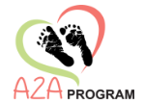
State of Missouri | Revised 4/2026
Missouri Department of Social SErvices (DSS)
Office of Workforce and Community Inititives (OWCI)
2026
Table of Contents

A2A State Program Contact Directory 2
A2A Program Resouce Links 2
Introduction & Overview 2
System Requirements 2
Computer Security Access 3
Computer Safeguards 3
User Role & Governance 3
Training Resources 3
Client Transfers 4
Setting up a Subcontractor 4
New User Setup (MO Login) 4
Create New User in the DSS A2A Database 5
Activating the User Account (MoLogin + Database) 6
Resolve Password or Login Issues 7
Removing a User From the DSS A2A Database 7
Navigation & Common Screens 7
Client Intake Form 7
Monthly Client Form 10
Supportive Services Reporting 10
Case Note Requirements 14
Client Case Note 14
Birthing Outcome Form 15
Edinburgh Postnatal Depression Scale (EDPS) Form 17
Client Discharge Form 20
Client Reassignment Form 21
Trouble Shooting Database Errors 22

A2A State Program Contact Directory
Program Staff Email
Monitoring Staff Email
Invoicing Staff Email
OWCI A2A Program Address: 3705 Missouri Boulevard, Second Floor, Jefferson City, MO 65109

A2A Program Resouce Links
Program Page
Database Login
Missouri A2A Program Page
Program Training Portal
Office of Administration - Awarded Contract and Bid Docs Search
Missouri Resource Guide
MissouriBUYS Statewide eProcurement System

Introduction & Overview
The DSS A2A database is the official system used to:
- Record client intake
- Determine income eligibility
- Manage ongoing case information
Each screen in the system builds upon previously entered data, making accurate and timely data entry essential.
The database is available twenty-four hours a day, seven days a week
- Users may occasionally be notified of scheduled updates or maintenance
- Follow all guidance provided during update periods to avoid data entry issues or system errors

System Requirements
Agencies must maintain minimum technical standards and adhere to DSS guidelines.
Agencies Responsibilities:
- Maintain at least one computer with:
  - A current operating system
  - A modern browser (e.g., Chrome or Edge)
  - Updated antivirus protection
  - Secure internet connection
- Complete all DSS security forms
- Develop written IT policies including:
  - Security protocols
  - Data backup processes
  - Password usage
  - Protection of DSS electronic data

Important: Agencies must adhere to all DSS program guidelines and may not impose additional eligibility requirements beyond those established by DSS. All eligibility determinations must comply with applicable federal regulations.

Computer Security Access
Access to the A2A database is restricted to authorized users.
Important:
System access is limited to authorized A2A contractor and subcontractor and DSS staff.
- Do not share A2A case information with non-A2A programs
- All staff must sign a DSS Confidentiality and Information Security Agreement
- Only authorized users will be granted access

Computer Safeguards
Built-in safeguards include:
- Automatic timeout after 10 minutes of inactivity
- SNN’s are masked after intake (only last 4 digits visible)
Staff Responsibility:
- Log off before leaving workstation
- Be aware of screen visibility
- Retrieve printed records immediately
- Store paperwork in a securely
- Shred documents before disposal

User Role & Governance
A2A Contractor:
- Administrator/Contractor Main Contact: Manages user access and caseload reassignment
- Staff: Manage assigned caseloads
Subcontractor:
- Administrator/Subcontractor Main Contact: Manages services and user access
- Staff: Manage assigned caseloads

Training Resources
Online Training is Available on the Office of Workforce and Community Initiatives Portal

Client Transfers
Transfers between agencies require DSS approval.
Process:
- Contact DSS A2A staff from the current contractor
- DSS A2A staff notify both agencies via email
- Do not discharge the client during the transfer
- Collection of enrollment verification is the responsibility of the contractor

Setting up a Subcontractor
Follow these steps to create a subcontractor in the A2A database.
Step 1: Request Setup
- Email the DSS A2A Program Staff
  - Include:
    - Subcontractor name
    - Primary contract name and email
    - Reason for setup

Step 2: Wait for Confirmation
- Once active, create users under the subcontractor
Important: Subcontractors must follow the same rules and requirements as contractors

New User Setup (MO Login)
Create and verify a MO LOGIN account before creating the user in the A2A database.
Step 1: Request a MO LOGIN Account
- Enter email
- Select Request Account

Step 2: Complete Verification
- Agree to terms
- A confirmation code will be sent to the provided email address
- The email will include a link to a form required to finish registering for a MO account
Important: The MO LOGIN verification code expires shortly. Complete registration promptly after receiving the email.
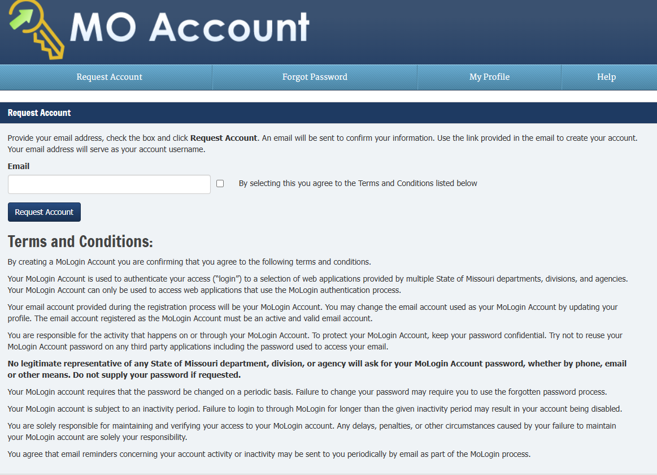

Create New User in the DSS A2A Database
Step 1: Navigate to the User Creation Page
- Hover over Users tab in the navigation bar
- Select New User
Step 2: Reporting Structure
In the field labeled “Select to whom the new user will report,” choose one option.
Option 1: This new user will directly report to me
- Select the users’ role:
- If the user is a Subcontractor, enter:
  - Subcontractor Name
  - First Name
  - Last Name
  - Email Address
Option 2: This new user will report directly to the selected Subcontractor
- Select the subcontractor’s name from the dropdown
- Enter:
  - First Name
  - Last Name
  - Email Address

Step 3: Submit User Information
- Select Submit to complete the user creation
- A notification email will be sent to the new user with an access code
Important: The access code is valid for 72 hours

Activating the User Account (MoLogin + Database)
After the user is created, they must activate their account using MO LOGIN and be marked active in the database.

Step 1: Access MOLogin
Step 2: Reset Password
- Select Forgot Password
- Enter your email address
- Select Send Code
Step 3: Retrieve Access Code
- Check your email for the code (check junk mail if not in inbox)
- Select the link in the email or return to MO Login
- Enter your email address and the access code
- Select Submit
Step 4: If No Email Received
- If you do not receive an email within 15 minutes, email Program Staff
- DSS A2A staff will send you a code
Step 5: Activate in Database
- After receiving the code, contact DSS A2A staff so they can mark you active in the database
- You will then see the activation confirmation screen

Resolve Password or Login Issues
If a user experiences issues with their password, (e.g., forgotten, expired, or reset problems), take the following steps:
Step 1: Notify DSS A2A State Program staff
Step 2: DSS staff will:
  - Verify whether the user still has access to the A2A database
  - Send a computer-generated email to the user with instructions, and access code, or a web link to reset the password

Removing a User From the DSS A2A Database
Step 1: Sign In
- Sign into the DSS A2A database using your User ID and password
Step 2: Navigate to User Maintenance
- Select Users
- Select User Maintenance from the drop-down menu
- Under State User or one of the other categories, select the user you wish to remove
Step 3: Change Status
- In the light grey area below the blue box where it states Status, select Inactive
Step 4: Submit
- Select Submit to complete the removal process

Navigation & Common Screens
Common screens used in A2A include:
- Client Intake Form
- Monthly Client Form
- Birthing Outcome Form
- Case notes
- Edinburgh Postnatal Depression Scale (EPDS) Form
- Discharge Form
- Client Reassignment
- Services by Intake Report
- Create New User

Client Intake Form
Follow these steps to enter a Client Intake form in the A2A database
Step 1: Client Intake Form
- From the Clients dropdown menu, select Client Intake Form
Step 2: Enter Client Information
- Enter all required client details
Step 3: Complete mandatory Fields
- Enter all mandatory fields; grayed out fields cannot be edited

Step 4: Submit the Form
- Select Submit
- Confirmation Message: “Client record successfully added.”

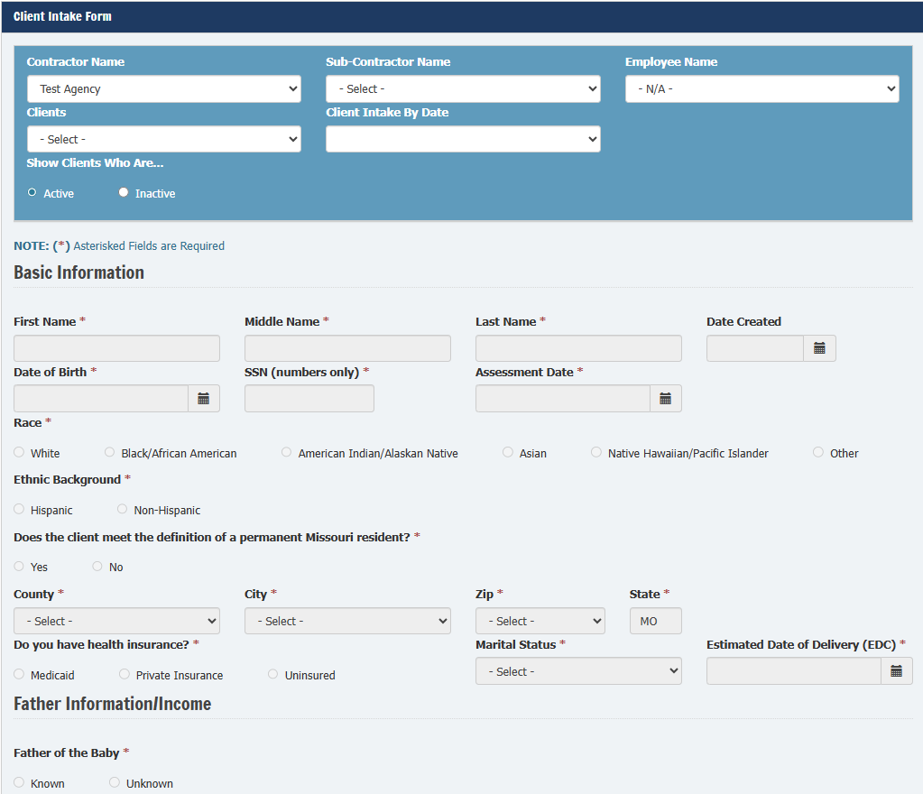
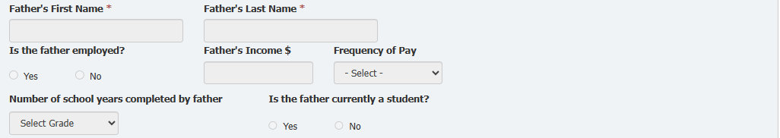
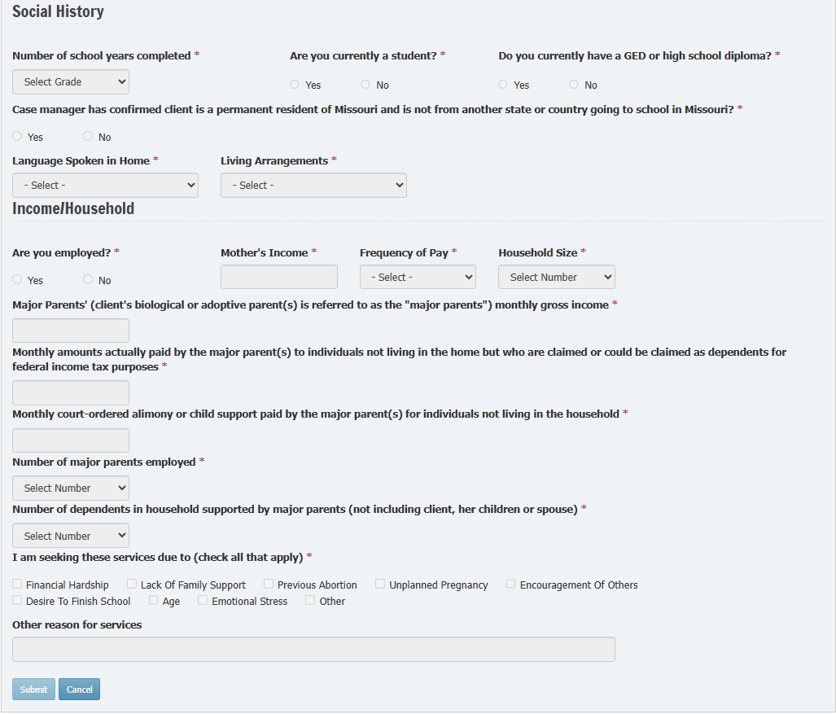

Monthly Client Form
Use the Monthly Client Form to document services to both residential and non-residential clients.
Follow these steps to enter a Monthly Client form in the A2A database
Step 1: Select Identifying Information
- From the dropdown menus, select:
  - Contractor Name
  - Subcontractor Name (if applicable)
  - Employee Name
  - Client Name
  - Client Intake Date
- Under Monthly From by Review Date, select New
- Enter all relevant required fields
- Select Submit
Important: This form is where Supportive Services for the client are recorded. When a service is recorded, a pop-up box will appear asking: “Have any/all other resources been exhausted prior to using A2A funds?”

TANF funds must be used only as a last resort. Before applying for A2A funds, providers must:
- Assist the client in identifying and using all available resources, and
- Document in case notes the steps taken and resources exhausted before using A2A funds.
Step 2: Submit the Form
- Select Submit
- Confirmation Message: “Data was successfully saved”

Submit for Residential Clients:
For residential care clients, no additional items are required after completing the mandatory fields.
- Select Submit to complete the Monthly Client Form for the reporting month.

Supportive Services Reporting
DO NOT REPORT DONATED ITEMS
Do not enter the following donated items on the Monthly Client Form, even if they were distributed:
- Clothing
- Food
- Personal hygiene items
- Supplies related to pregnancy, newborn care or parenting

Important: Only contractor funded supportive items should be reported. Do not report donated goods (e.g., clothing, food, hygiene items, or parenting supplies) on the Monthly Client Form.
Report Contractor Funded Supportive Services for Non-Residential Clients
Staff must enter any supportive service items provided to non-residential clients that were funded by the contractor. These may include:
- Transportation
- Diapers or formula
- Gift cards
- Utility or rent assistance
- Other contractor-funded support items

Monthly Client Form-Supportive Services Chart
Category | Subcategory
Childcare | Childcare Co-payment
Childcare | Childcare Registration Fees & Other Childcare Fees Not Paid for through Subsidies
Clothing | Clothing
Drug/Alcohol Testing | Drug/Alcohol Testing
Drug/Alcohol Testing | Drug Treatment
Drug/Alcohol Testing | Substance Awareness Traffic Offender Program (SATOP) Class
Educational Services | College Application and Entry Test Fees
Educational Services | College Fees
Educational Services | Education & Training
Educational Services | GED or HISET Test Fees
Educational Services | Work and/or School Supplies Required for Employment & Training
Food | Food
Housing Services | Emergency Shelter-Housing
Housing Services | Mortgage Payments
Housing Services | Rent and/or Rent Security Deposit
Legal | Criminal Background Check
Legal | Domestic Abuse Protection
Legal | Legal Costs, Fines, Penalties, etc.
Legal | Paternity Testing
Medical Expenses | Dental Expenses
Medical Expenses | Medical Expenses
Medical Expenses | Mental Health Services
Medical Expenses | Prenatal Care
Medical Expenses | Vision Expenses
Supplies | Personal Hygiene Items
Supplies | Supplies Related to Pregnancy, Newborn Care and Parenting
Transportation Services | Automobile Lease or Loan Payment
Transportation Services | Automobile Insurance
Transportation Services | Automobile Repair(s)
Transportation Services | Bicycle or Bicycle Parts
Transportation Services | Bus Passes/Tickets
Transportation Services | Drivers/Non-Driver’s License Fees
Transportation Services | Gas Cards, & Mileage Reimbursement
Transportation Services | Personal Property Taxes
Utility Assistance | Basic Phone Service
Utility Assistance | Cellular Phone Service
Utility Assistance | Electric
Utility Assistance | Phone-Airtime
Utility Assistance | Trash
Utility Assistance | Utilities Including Heating and Cooling
Utility Assistance | Water

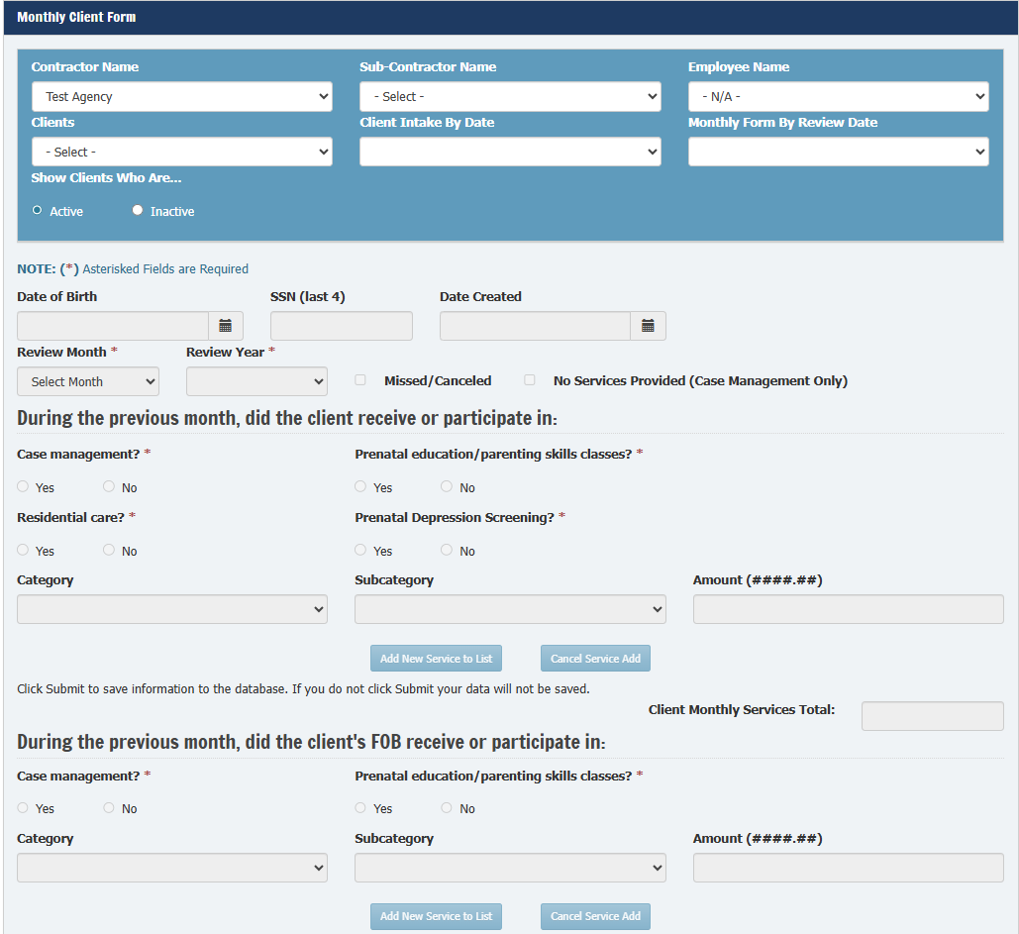
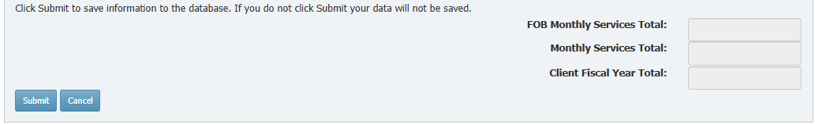

Case Note Requirements
- Timing:
  - Enter when services are rendered or by the 15th of the following month
- Format:
  - Notes remain electronic
- Content Requirements:
  - Clear and factual
  - Support staff decisions
  - Suitable for hearings or audits
- Limit:
  - 2,500 characters per note
  - Use multiple entries if needed
- Copy/Paste:
  - Allowed from other systems

Client Case Note
Follow these steps to enter a Client Case Note in the A2A database
Step 1: Client Case Notes Form
- From the Clients drop down menu, select Client Case Notes Form
Step 2: Complete Identifying Fields
- From the dropdown menus, select:
  - Contractor Name
  - Subcontractor Name (if applicable)
  - Employee Name
  - Client Name
Step 3: Add a Client Case Note
- Select Add Client Note
- Enter your note (up to 2,500 characters)
Step 4: Submit the Note
- Select Add Case Note to save the entry
Important: If a case note needs to be deleted, refer to the A2A Provider Handbook for detailed instructions and deletion procedures.
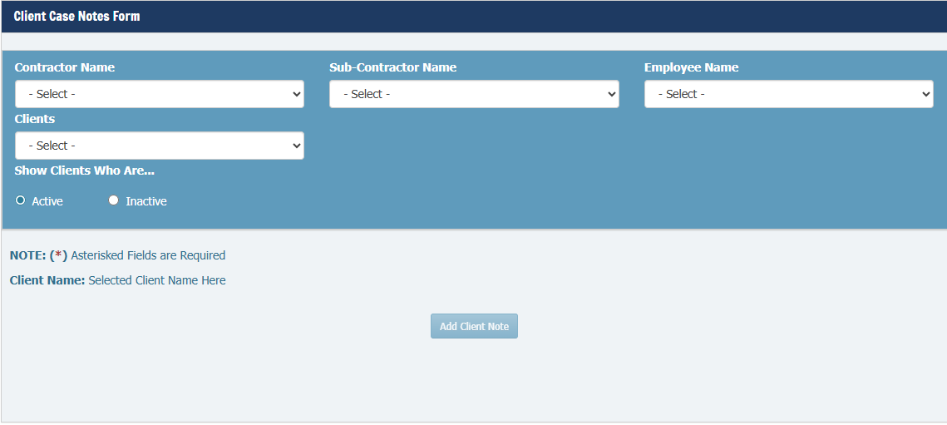

Birthing Outcome Form
Follow these steps to enter a Birthing Outcome Form in the A2A database
Step 1: From the Clients dropdown menu, select Birthing Outcome Form
Step 2: Complete identifying Fields
- From the drop-down menus, select:
  - Contractor Name
  - Subcontractor Name (if applicable)
  - Employee Name
  - Client Name
  - Client Intake Date
Step 3: Delivery Date
- Under Birthing Form by Delivery/Left Date, select New
Step 4: Enter Birthing Details
- Enter all required data fields

Database Issue:- Maternal Health Section
- When completing a Birthing Outcome Form with any of the following outcomes: Discharged Before Delivery, Miscarriage, Elective Abortion, or Stillbirth, the Delivery Date field will remain greyed out and cannot be entered.
- For these outcomes:
  - Enter all required information on the form
  - Email the DFAS.A2A inbox with the outcome date:
  - ITSD must enter the date for the system to allow additional monthly client forms to be submitted.
Step 5: Submit the Form
- Select Submit at the bottom of the page to save the form

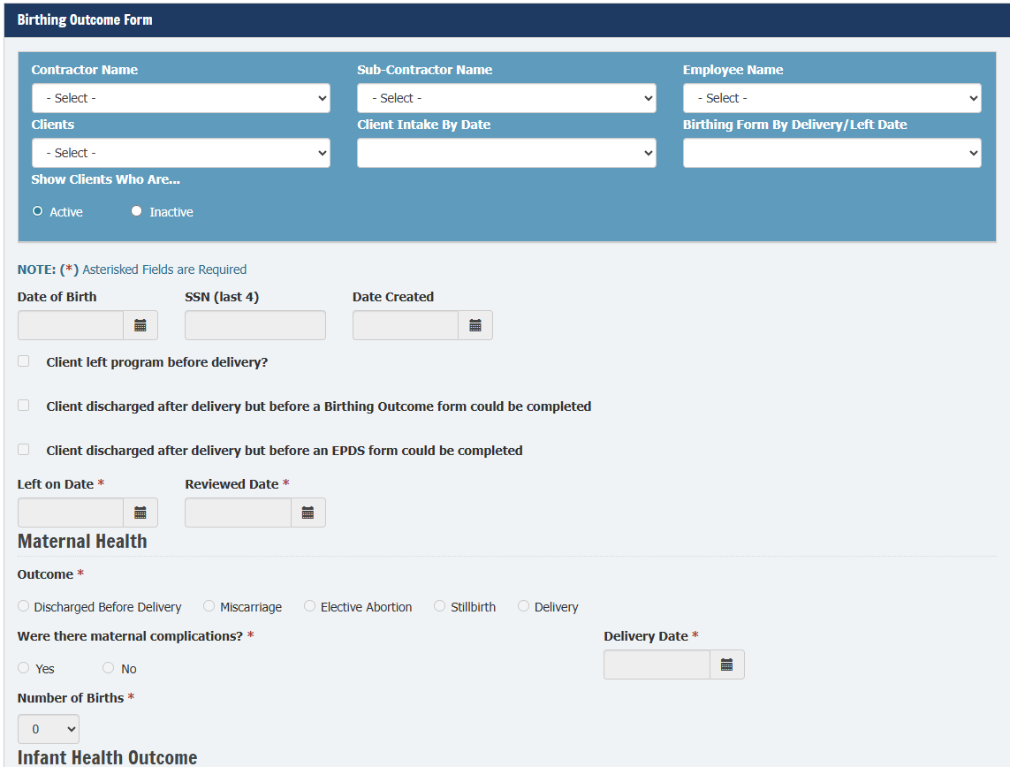
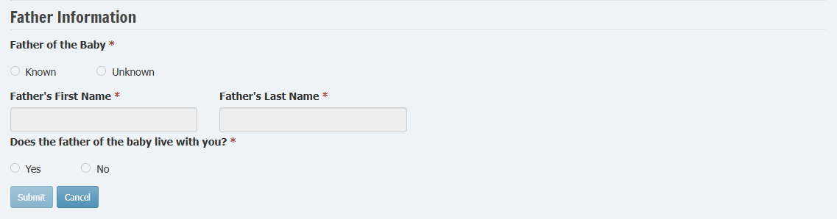

Edinburgh Postnatal Depression Scale (EDPS) Form
Follow these steps to enter an EDPS form in the A2A database
Step 1: EPDS Form
- From the Clients dropdown menu, select Edinburgh Postnatal Depression Scale (EDPS) Form
Step 2: Complete Identifying Fields
- From the dropdown menus, select:
  - Contractor Name
  - Subcontractor Name (if applicable)
  - Employee Name
  - Client Name
  - Client Intake Date
Step 3: Review Date
- Under Postnatal From by Review Date, select New
Step 4: Screening Details
- Enter all required data fields
Step 5: Submit the Form
- Select Submit at the bottom of the page to save the form
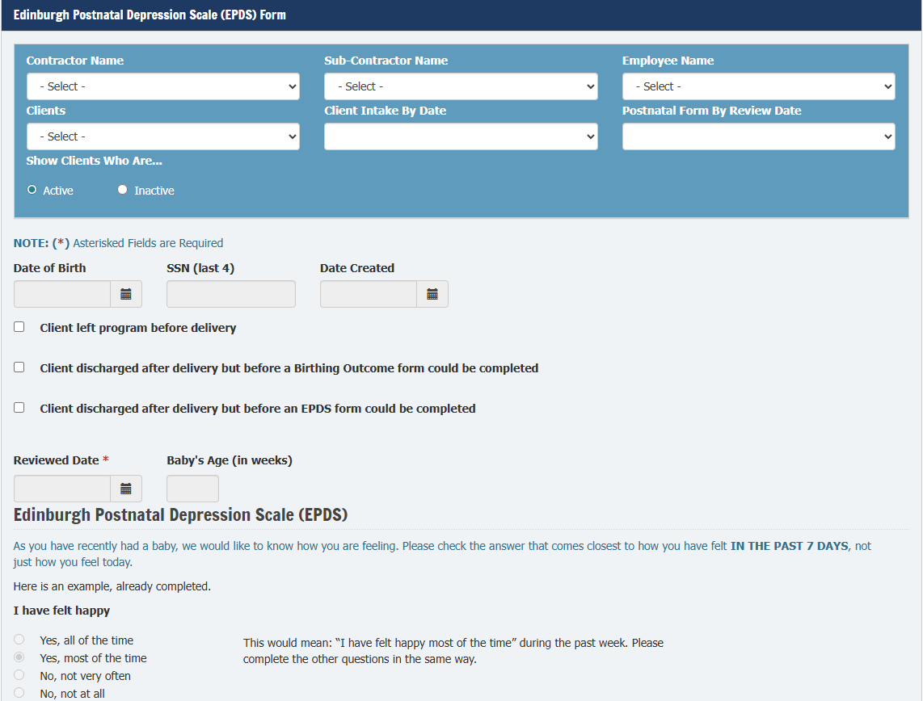
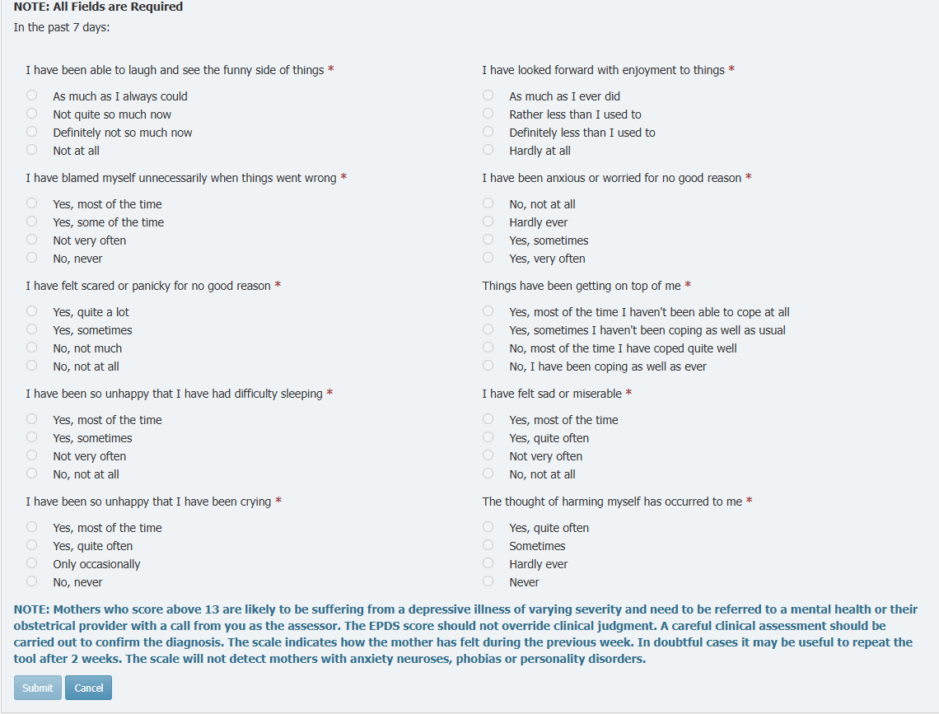

Client Discharge Form
Follow these steps to enter a Client Discharge form in the A2A database
Step 1: Discharge Form
- From the Clients drop down menu, select Client Discharge Form
Step 2: Complete Identifying Fields
- From the dropdown menus, select:
  - Contractor Name
  - Subcontractor Name (if applicable)
  - Employee Name
  - Client Name
  - Client Intake Date
Step 3: If Client Left Before Delivery
- Complete the following forms before discharge:
  - Birthing Outcome Form
- EPDS Form
On each form:
  - Check the box labeled “Client left program before delivery”
  - Enter the date the client left the program
- Select the appropriate reason for discharge from the dropdown
Step 4: Return to the Discharge Form
- Enter all required fields

Step 5: Submit the Form
- Select Submit at the bottom of the page to complete the discharge process
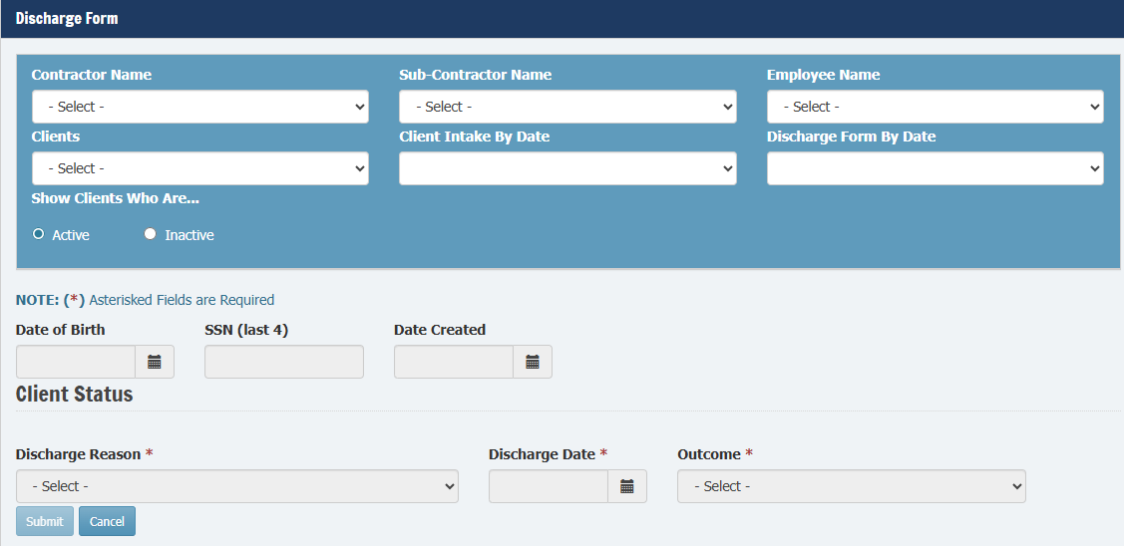

Client Reassignment Form
Only DSS State Program staff can transfer clients between Contractors. However, internal transfers are allowed.

Step 1: Client Reassignment
- From the Clients dropdown menu, select Client Reassignment
Step 2: Search for the Client
- Type the client’s name into the search bar
- Select Search
Step 3: Add Client to Transfer List
- Select Add next to the client’s name
- Repeat this step for each client you wish to transfer or reassign

Internal Transfers
- Agencies may transfer clients between their own subcontractors or employees
- Subcontractors may reassign clients internally between their own employees
Important:
Only DSS State Program staff may transfer clients between contractors. Contractor’s and subcontractors may reassign clients internally among subcontractors or employees.

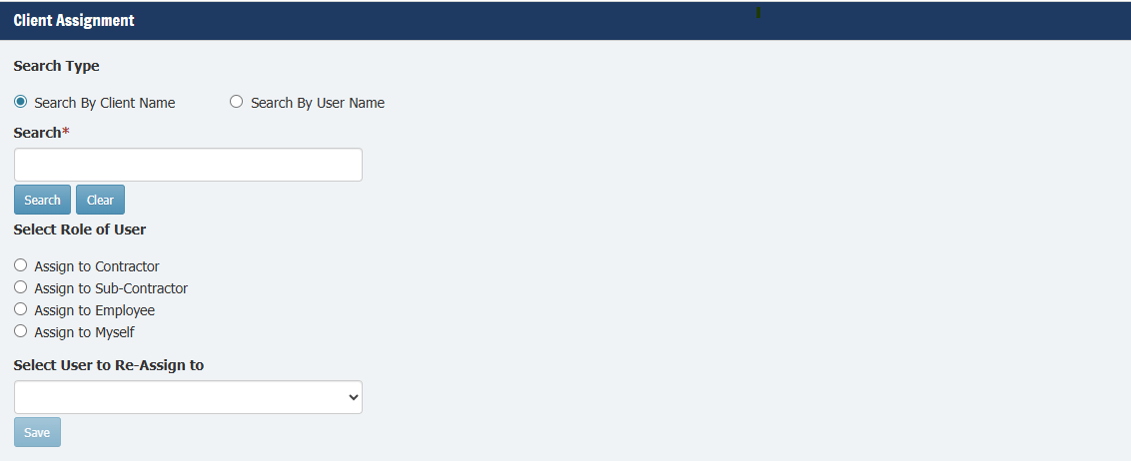

Trouble Shooting Database Errors
Occasionally, users may encounter minor database errors or unexpected behavior when navigating the A2A system. In these cases:
- Clear web browser history, cache, and cookies
- Refresh or restart browser
- Contact DSS if issue persists

End of Document

