Missouri Department of Social Services

Family Support Division

Temporary Assistance for Needy Families

Senate Bill 24 Annual Report

2024

The 98th Missouri General Assembly passed Senate Bill 24 during the 2015 Regular Session. The following list details the changes that this legislation mandated:

- Standardized orientation for TANF applicants that informs them of program rules, requirements, work activities and consequences if program requirements are not satisfied prior to application approval.

- TANF applicants shall sign a participation agreement known as a “Personal Responsibility Plan” prior to application approval unless the individual is exempt from work activities.

- TANF applicant must login to or create an account at jobs.mo.gov prior to application approval unless the individual is exempt from work activities.

- Cash Diversion Program that grants eligible TANF applicants, otherwise eligible for the TANF program, a lump-sum cash grant for short term needs in lieu of ongoing monthly TANF payments.

- Sanction policies for non-cooperation with work requirements:

  - Division will schedule a face-to-face meeting with the recipient to explain participation requirements and the sanction policy.

  - The recipient has six (6) weeks from the date of the face-to-face meeting to comply with work requirements for one (1) week, regardless of whether they attend the meeting.

  - If the participant does not comply during this six (6) week period, the Division shall reduce the amount of assistance otherwise payable to the household by fifty percent (50%) of the full grant amount.

  - The household will receive the reduced grant for up to ten (10) weeks if they remain eligible for Temporary Assistance on all other factors during that time. When the Temporary Assistance benefit has been reduced by 50%, the participant is required to complete four (4) consecutive weeks of participation in work activities for a minimum average of thirty (30) hours per week or the required hours allowable under the Fair Labor Standards Act (FLSA) before the sanction can be ended.

  - The ten (10) week period provides the individual additional time to comply with work requirements. When the participant has completed four (4) consecutive weeks of the required hours per week, the sanction will end.

  - Failure to complete four (4) consecutive weeks of participation for the minimum average required hours per week by the end of the ten (10) week period will result in a full-family sanction and the Temporary Assistance case closing.

- New Spouse Disregard – A Temporary disregard of all income and resources of a new spouse when they marry an active Temporary Assistance recipient. This disregard is available for six (6) consecutive months the Temporary Assistance participant receives a cash benefit. It is allowed once-in-a-lifetime for the Temporary Assistance recipient that marries, and applied to both parents in a two
(2) parent household that marry, if both are active cash recipients on the marriage date.

- Reduced life time limit to receive TANF benefits from Sixty (60) months to forty- five (45) months unless approved for a hardship extension.

- Create a database in conjunction with the Department of Economic Development for tacking and recording TANF recipient’s work activities.

The following data was collected for Federal Fiscal Year 2024

- Number of TA applications rejected prior to approval for non-compliance with new requirements- 782

- Number of Cash Diversion Cases- 1 totaling $702 in payments

- Number of 50% Sanctions:
  - 2,623 households consisting of
    - 5,136 children;
      - 2,503 of those under age 5
  - 363 resolved 50% sanctions

- Number of Full Family Sanctions:
  - 1,837 households consisting of
    - 3,561 children;
      - 1,687 of those under age 5
  - ** resolved Full Family Sanctions

- Number of New Spouse Disregard TANF cases- 0

- Number of TANF cases closed for the 45 month life time limit:
  - 174 households consisting of
    - 441 children;
      - 153 of those under age 5

- TANF participant logon hours with job.mo.gov
  - Total Participants: Hours logged: **
* Previous years included duplicated participant logon hours

**This information was requested but can no longer be provided

Senate Bill 24 Implementation Costs

There were no implementation costs for FFY 2024. All implementation costs were incurred in previous fiscal years.

Temporary Assistance Families
60-Month Trend through September 2024

(The graph reflects total number of families receiving benefits prior to SB24 thru implementation and current FFY 24)*

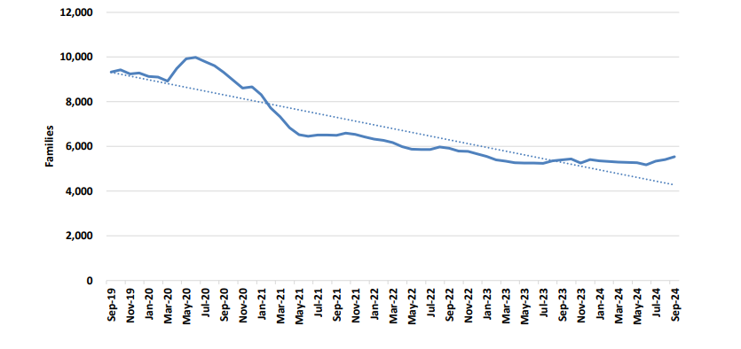
MISSOURI DEPARTMENT OF SOCIAL SERVICES TEMPORARY ASSISTANCE CASELOAD DEMOGRAPHICS
UNDUPLICATED COUNT OF ALL ACTIVE TANF INDIVIDUALS IN FEDERAL FISCAL YEAR 2024
 |  |  | 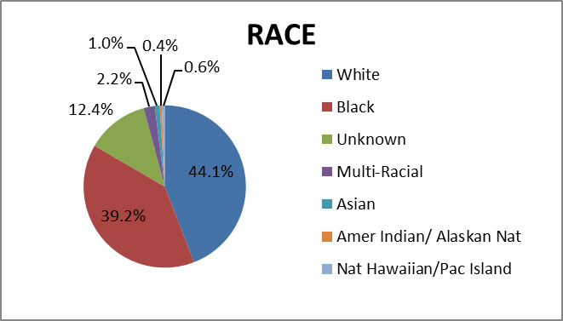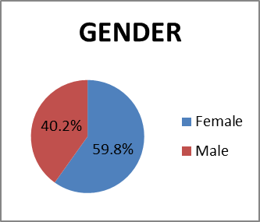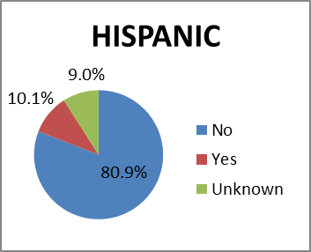
RACE | NUMBER | PERCENT
White | 10,768 | 44.1%
Black | 9,574 | 39.2%
Unknown | 3,034 | 12.4%
Multi-Racial | 540 | 2.2%
Asian | 236 | 1.0%
Amer Indian/ Alaskan Nat | 102 | 0.4%
Nat Hawaiian/Pac Island | 142 | 0.6%
Total | 24,396 | 100%
HISPANIC | NUMBER | PERCENT
No | 19,740 | 80.9%
Yes | 2,456 | 10.1%
Unknown | 2,200 | 9.0%
Total | 24,396 | 100%
GENDER | NUMBER | PERCENT
Female | 14,601 | 59.8%
Male | 9,795 | 40.2%
Total | 24,396 | 100%

MISSOURI DEPARTMENT OF SOCIAL SERVICES TEMPORARY ASSISTANCE CASELOAD DEMOGRAPHICS
UNDUPLICATED COUNT OF ALL ACTIVE TANF INDIVIDUALS IN FEDERAL FISCAL YEAR 2024
AGE | NUMBER | PERCENT
< 18 | 17,391 | 71.3%
18-25 | 1,875 | 7.7%
26-35 | 3,122 | 12.8%
36-45 | 1,545 | 6.3%
46-50 | 266 | 1.1%
51-59 | 168 | 0.7%
60-64 | 21 | 0.09%
65 + | 8 | 0.03%
Total | 24,396 | 100%
EDUCATION LEVEL (AGE 18-64 ONLY) | NUMBER | PERCENT
HIGH SCHOOL GRADUATE | 3,548 | 50.7%
SOME HIGH SCHOOL | 1,483 | 21.2%
SOME COLLEGE | 1,144 | 16.3%
COLLEGE GRADUATE | 229 | 3.3%
ELEMENTARY SCHOOL | 180 | 2.6%
OTHER | 378 | 5.4%
MASTERS | 33 | 0.5%
DOCTORATE | 2 | 0.03%
Total | 6,997 | 100%
NOTE: TA data excludes individuals active on TEB.

DFAS no longer runs the SB24/TANF Reinvestigation Report. This information can no longer be added to this report.

